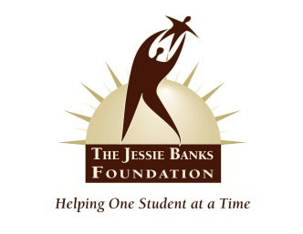

The Jessie Banks Foundation
Scholar Agreement 2022

Please carefully read, initial and sign where indicated. It is the SCHOLAR’s sole responsibility to submit all required documents within the appropriate time frame.

All Documents can be mailed to:

650 Palisades Ave
Suite 2-127
Englewood Cliffs, NJ 07632

For questions Email:
scholarships@jessiebanksfoundation.org

- Scholar: A recipient of JBF Scholarship.

- Scholarship: A recognition of honor given at JBF’s Gala for the application year and set monetary Award toward tuition

- Award: Funds will be paid directly to an accredited institution, on behalf of the fulltime enrolled Scholar, by the Jessie Banks Foundation. Funds are paid within three (3)
Academic Terms, from Scholar’s acknowledgement at JBF Gala.
Funds will be disbursed evenly between two (2) semesters. Academic terms are defined by the Institution and may include a Summer Session.

The Jessie Banks Foundation
Scholar Agreement 2022

Please initial on the lines and sign where indicated.

I am selected as a JBF Scholar:

_____ I understand that in order to receive my award, I must be present at the Scholarship Awards Gala on Thursday, November 3, 2022 or I forfeit the award.

_____ I understand the JBF Award will be distributed evenly between two (2) semesters within the 2022-2023 calendar year. The first distribution will be in the Spring 2023 and the second distribution will followed by my attendance at the JBF 2023 Annual June Seminar.

_____ I give The Jessie Banks Foundation permission to use my name, photo and school information in Marketing Materials.

_____ I agree to forward semester updates including employment, volunteer service, activities and
achievements by way of email, letters and photos through Graduate School.

A _____ I understand that in order for my Award to be tendered to the institution, in which I will matriculate, I AM RESPONSIBLE FOR SUBMITTING THE FOLLOWING SEALED SCHOOL OFFICIAL DOCUMENTATION TO THE JESSIE BANKS FOUNDATION!
- Proof of full time registration enrollment from Institution
- Bursar Bill indicating opening balance of $2,000.00 or greater for Academic Term submitted
- A Thank you card or professional letter from Scholar to The Jessie Banks Foundation, by US Mail Prior to check distribution

B_____ I must participate in one (1) Annual JBF Seminar and one (1) Community Service Outreach Program, as approved by JBF board, prior to receiving the second and final installment of award.

______ If I fail to submit required documentation to JBF within the required time frame (Above see Award definition) nor participate in JBF’s Education & Community Outreach Program, as outlined in
the Jessie Banks Foundation bylaws, I understand that I will forfeit the Award.

______________________________________________________________ __________________
Student Signature Date

______________________________________________________________ __________________
Parent Signature Date

